Cenozoic Climates

“The immediate mitigation rate is increased to over 10% per annum, and the time to deliver a fully decarbonized energy system is brought forward to 2035-40. Such a challenging mitigation agenda implies profound changes to many facets of industrialized economies.” Kevin Anderson, John F. Broderick and Isak Stoddard [Anderson]

Tony Noerpel

The Cenozoic Era began 66 million years ago with the collision of a six-mile diameter meteorite into what is now the Yucatán Peninsula, Mexico. This collision famously wiped out the dinosaurs and vast numbers of other species and gave rise to the current age of mammals. The Earth climate at the time was a hothouse climate, as it was for the late Mesozoic which preceded the Cenozoic. The Cenozoic climate is shown in Figure 1 from [Westerhold]. It is a complex chart but rather important. The upper curve is the ratio of heavy oxygen to light oxygen in certain benthic foraminifera shells recovered from deep ocean sediment drilling. Benthic refers to the bottom of the ocean, i.e., organisms which live in the deep ocean. The isotope ratio (called fractioning in the scientific literature) is a proxy for temperature [Westerhold-SM]. The conversion to mean temperature difference relative to today is shown on the far right.

The paper identifies four climate states: hothouse, warmhouse, coolhouse and ice house. I’ve identified these four states in Figure 1. I don’t know why the authors don’t split the coolhouse during the Miocene, from 34 million years ago (Ma) to 6 million years ago into two climate states since there is a distinct 4-degree climate change at the mid-Miocene Climate Transition (mMCT) 13.9 Ma. In fact in the supplementary material accompanying the publication they write: “*After the mMCT at 13.9 Ma, Earth‘s climatic regime and dynamic response changed with the re-expansion of Antarctic ice sheets and possible initiation of Northern Hemisphere Ice Sheets (NHIS) in the late Miocene. After that time, a persistent response to obliquity gains power in the oxygen isotope signal, further strengthening after 7.7 Ma*.” This distinction seems to be particularly relevant to the current situation because we seem to be headed for an early Miocene climate with no Northern Hemisphere or West Antarctic Ice sheets rather than a state with permanent ice on both poles. In other words, a four-degree warmer world even in the best-case scenario may be likely.

Figure 2, also from this paper, shows that the current atmospheric carbon dioxide load (415 parts per million by volume or ppmV) is already the highest it has even been in an icehouse state. But the carbon dioxide equivalent load (CO2-eq.), including the other greenhouse gases, is already at 500 ppmV [NOAA] and even the most aggressive response to climate change would barely keep us under 580 to 650 ppmV CO2-eq, adding in the effect of carbon cycle feedbacks, 30 to 100 ppmV [Schwalm]. These levels of atmospheric carbon are entirely consistent with an early Miocene climate before the mMCT, i.e., a 4-degree warmer world and far outside the current icehouse climate state. This is important because the most recent estimate for equilibrium climate sensitivity (ECS) [Sherwood] of between 2.6 nd 3.9 degrees is entirely based on icehouse conditions and therefore implicitly assumes bipolar ice sheets and may therefore, have reduced applicability to our future climate if it transitions into a coolhouse or warmhouse state with only southern hemisphere ice.

Historically, all models have supported an ECS between 1.5 and 4.5 K with a median value of 3 K and all of these models have failed to predict the rapid melting of Arctic sea ice as shown in Figure 3, from a paper by Kristina Pistone and colleagues [Pistone]. Research by Maria-Vittoria Guarino and colleagues [Guarino] shows that one of the newer models, the UK Hadley Center climate model (HadGEM3), with ECS equal to 5.5 K outperforms older models by correctly hindcasting the current Arctic sea ice retreat and the Arctic sea ice retreat during the last interglacial 130,000 to 116,000 years before the present. [Guarino] forecasts the Arctic Sea will be ice free by 2035, well ahead of predictions by older models with lower sensitivity to atmospheric carbon dioxide. The HadGEM3 sensitivity is in agreement with the sensitivity forecast by the Community Earth System Model version 2 (CESM2) of 5.3 K [Getterman]. An ice-free Arctic Ocean replaces highly reflective ice and snow with dark light absorbing water. This change in albedo or reflectivity increases the Earth radiation imbalance by about 0.71 Watts per meter squared (W/m^2) which is equivalent to about a trillion tons of carbon dioxide emissions. Climate models with a lower sensitivity have to add about 57 ppmV to the atmospheric carbon dioxide load to more accurately forecast the level of warming according to [Pistone]. Higher sensitivity models incorporate this effect by more accurately modeling sea ice melt.

Several papers report that ice loss is linear with respect to both temperature anomaly and emissions and a paper by Dirk Notz and Julienne Stroeve shows that Arctic sea ice retreats at a rate of 3 square meters for every ton of carbon dioxide emissions and estimate that the Arctic Ocean will be ice free by 2050 [Notz]. But there is no reason to believe the observed linearity will persist. In fact, there is compelling science that it will not. The physics is similar to that which occurred during D-O events as described by [Jansen] and as observed currently by [Polyakov]. The Arctic Ocean is stratified having a layer of ice on top, a layer of cold salty water below that, which insulates the ice from warmer Atlantic water at the bottom. Thus, the ice has only been exposed to warmer air from above causing the observed melting. However, the cold salty layer is becoming mixed with the warmer water below and when this happens the ice will be melted from below as well and there is enough heat in these bottom waters to maintain an ice-free state even during the winter [Polyakov].

Therefore, it is not surprising that research by Maria-Vittoria Guarino [Guarino] using HadGEM3 is forecasting an ice-free Arctic sea before 2035. According to Jansen et al. this may be the trigger for abrupt climate change globally [Jansen] similar to the D-O events. When the Arctic sea ice disappears, Greenland’s great ice sheet will be exposed to warm Atlantic water on all sides accelerating land glacier loss and sea level rise. This event may have already passed a tipping point a decade ago according to a pair of recent papers by Michaela King et al. [King] [Sasgen]. For the record, at 2 K warming, the West Antarctic Ice sheet is also passed an unrecoverable tipping point [Garbe].

We cannot predict what we will do in the future regards emitting greenhouse gases and therefore the IPCC has developed several scenarios or emissions trajectories. The one that models the highest level of GHGs is known as the Business-As-Usual (BAU) emissions scenario, formally Representative Concentration Pathway or RCP8.5. This scenario has been criticized by commentators and characterized as extreme, alarmist, and “misleading”, with some commentators going so far as to dismiss any study using RCP8.5 [Schwalm]. However, as [Schwalm] shows, RPC8.5 emissions most accurately reflect actual emissions since 2005 to 2020 and may be the most appropriate out to mid-century. Ironically, the lowest emissions scenario RCP2.6, the only scenario which achieves a climate lower than 2 K warmer, is not just misleading but impossible and highly immoral as it requires massive amounts of negative emissions, which we do not know how to do at scale and cost both energy and land, not to us, but to our children and grandchildren. And in any event as much as we are relying on this non-existent technology we are not adequately investing in the necessary research. We are leaving future generations a mess and expecting them to clean it up. RCP2.6 scenarios also assume transient climate sensitivity rather than ECS so they are not physically possible [Anderson].

Figure 4 shows estimated global temperature anomalies of three International Energy Agency emissions scenarios from their 2018 report and the most plausibly aggressive emissions reduction scenario being considered, getting us to zero-emissions by 2050. Importantly, only a few countries even have aspirations to be carbon-free by 2050 and there are no actual plans to achieve this [Darby].

I have assumed two values for ECS to bound the problem: 2.6 K, which is the lowest “likely” value [Sherwood] and 5.3 K, which is the estimate from the CESM 2 model [Getterman] and estimated the resultant temperature anomaly using the simple equation I gave last week. To the aggressive model, I’ve added 31 ppmV, the low end of assumed carbon cycle feedbacks and for the other cases I’ve used 102 ppmV representing the high end for carbon cycle emissions. I’ve only added these additional emissions when considering the best case ECS as these models do not forecast an ice free arctic and carbon cycle feedbacks are not included by the IPCC [Anderson]. I do not add any additional carbon to the high ECS models since I’m assuming these are two of the possible reasons they predict higher sensitivity.

Conclusions from [Anderson] cited above are based on the low range of climate models.

To be continued.

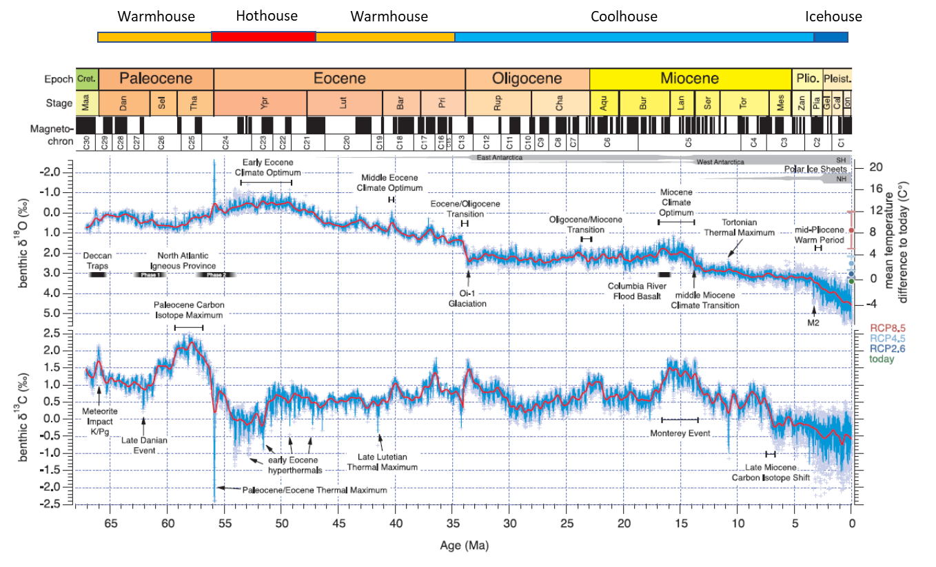

Figure 1. The upper curve is the bethic oxygen isotope fraction which is a proxy for global mean temperature shown on the right relative to today’s climate. I’ve added the climate state at the top of the chart identifying state transitions as described in the text. Source: [Westerhold].



Figure 2. the Cenozoic climate shows distinct states. Note that current atmospheric carbon dioxide is at the limit of the current ice house state suggesting that we are very close to causing a state transition of the climate system into a different state. Source: {Westerhold].



Figure 3. “*Annual-mean Arctic sea ice cover and global-mean temperature in Coupled Model Intercomparison Project Phase 5 climate model simulations. (a) The 1979 baseline sea ice extent (see Appendix A). (b) The change in sea ice extent per change in global-mean temperature (i.e., the sea ice sensitivity). (c) Estimate of the level of global warming relative to 1979 at which the Arctic Ocean becomes completely ice free, which is the ratio of the value in panel (a) to the value in panel (b). The processed model output is adopted from Rosenblum and Eisenman (2017). The solid red line in each panel shows ice extent and global-mean temperature values from the observational record. Details are given in Appendix A*.” [Pistone]

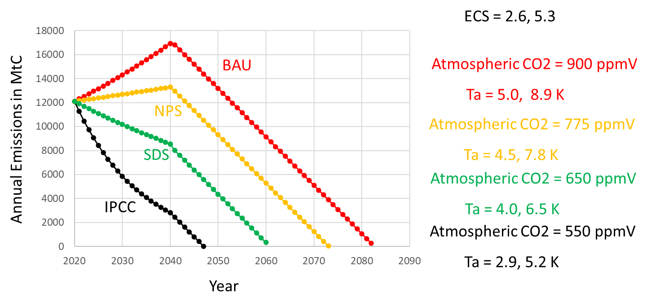

Figure 4. Emissions include fossil fuels, concrete, land use changes but do not include carbon cycle feedbacks, also other GHGs are not included. I assume no negative emissions. I’m assuming we discover some amount of wisdom in 2040 and begin to act responsibly. International Energy Agency scenarios “World Energy Outlook”: Business as usual (BAU), Sustainable Development Scenario (SDS) and New Policies Scenario (NPS).

[Anderson] Kevin Anderson , John F. Broderick & Isak Stoddard (2020): A factor of two:

how the mitigation plans of ‘climate progressive’ nations fall far short of Paris-compliant pathways,

Climate Policy, <https://doi.org/10.1080/14693062.2020.1728209>

[Darby] Megan Darby and Isabelle Gerretsen, updated 28 October, 2020, <https://www.climatechangenews.com/2019/06/14/countries-net-zero-climate-goal/>

[Elkins-Tanton] Elkins-Tanton, L.T., et al., 2020, Field evidence for coal combustion links the 252 Ma Siberian Traps with global carbon disruption: Geology, v. 48, <https://doi.org/10.1130/G47365.1>

[Garbe] Julius Garbe, Torsten Albrecht, Anders Levermann, Jonathan F. Donges & Ricarda Winkelmann, The hysteresis of the Antarctic Ice Sheet, Nature, 23 September, 2020, <https://doi.org/10.1038/s41586-020-2727-5>

[Gettelman] Gettelman, A. et al. High climate sensitivity in the Community Earth System Model version 2 (CESM2). Geophys. Res. Lett. 46, 8329–8337 (2019).

[Guarino] Maria-Vittoria Guarino, Louise C. Sime, David Schröeder, Irene Malmierca-Vallet, Erica Rosenblum, Mark Ringer, Jeff Ridley, Danny Feltham, Cecilia Bitz, Eric J. Steig, Eric Wolff, Julienne Stroeve and Alistair Sellar, Sea-ice-free Arctic during the Last Interglacial supports fast future loss, Nature Climate Change, 10 August 2020, https://doi.org/10.1038/s41558-020-0865-2

[NOAA] <https://www.esrl.noaa.gov/gmd/aggi/>

[Jansen] Eystein Jansen, Jens Hesselbjerg Christensen, Trond Dokken, Kerim H. Nisancioglu, Bo M. Vinther, Emilie Capron , Chuncheng Guo, Mari F. Jensen, Peter L. Langen, Rasmus A. Pedersen, Shuting Yang, Mats Bentsen, Helle A. Kjær, Henrik Sadatzki, Evangeline Sessford and Martin Stendel, Past perspectives on the present era of abrupt Arctic climate change, Nature Climate Change, Vol. 10, August 2020, <https://doi.org/10.1038/s41558-020-0860-7>

[King] Michalea D. King, Ian M. Howat, Salvatore G. Candela, Myoung J. Noh, Seonsgu Jeong, Brice P. Y. Noël, Michiel R. van den Broeke, Bert Wouters and Adelaide Negrete, August 13, Dynamic ice loss from the Greenland Ice Sheet driven by sustained glacier retreat, Nature Comm. Earth & Env., (2020), <https://doi.org/10.1038/s43247-020-0001-2>

[Notz] Notz, D., & Stroeve, J. (2016). Observed Arctic sea-ice loss directly follows anthropogenic CO2 emission. Science, 354(6313), 747–750. <https://doi.org/10.1126/science.aag2345>

[Pistone] Pistone, K., Eisenman, I., & Ramanathan, V. (2019). Radiative heating of an ice-free arctic ocean. Geophysical Research Letters, 46, 7474–7480. <https://doi.org/10.1029/2019GL082914>

[Polyakov] Igor Polyakov et al., Weakening of Cold Halocline Layer Exposes Sea Ice to Oceanic Heat in the Eastern Arctic Ocean, 15 September 2020, <https://doi.org/10.1175/JCLI-D-19-0976.1>

[Sasgen] Ingo Sasgen, Bert Wouters, Alex S. Gardner, Michalea D. King, Marco Tedesco, Felix W. Landerer, Christoph Dahle, Himanshu Save & Xavier Fettweis, Return to rapid ice loss in Greenland and record loss in 2019 detected by the GRACE-FO satellites. Commun Earth Environ 1, 8 (2020). <https://doi.org/10.1038/s43247-020-0010-1>

[Schwalm] Christopher R. Schwalm, Spencer Glendon, and Philip B. Duffy, RCP8.5 tracks cumulative CO2 emissions, PNAS, August 18, 2020, vol. 117, no. 33, [www.pnas.org/cgi/doi/10.1073/pnas.2007117117](http://www.pnas.org/cgi/doi/10.1073/pnas.2007117117)

[Sherwood] Sherwood, S, M Webb, J Annan, K Armour, P Forster, J Hargreaves, G Hegerl, et al. 2020. "An assessment of Earth's Climate Sensitivity Using Multiple Lines of Evidence." Reviews of Geophysics. <https://doi.org/10.1029/2019RG000678>

[Westerhold] Westerhold et al., An astronomically dated record of Earth’s climate and its predictability over the last 66 million years, Science 369, 1383–1387 11 September 2020, <https://doi.org/10.1126/science.aba6853>

[Westerhold-SM] science.sciencemag.org/content/369/6509/1383/suppl/DC1

For more on the high sensitivity models see:

Tatebe, H. et al. Description and basic evaluation of simulated mean state, internal variability, and climate sensitivity in MIROC6. Geosci. Model Dev. 12, 2727–2765 (2019).

Voldoire, A. et al. Evaluation of CMIP6 deck experiments with CNRM-CM6-1. J. Adv. Model. Earth Syst. 11, 2177–2213 (2019).

Wu, T. et al. The Beijing Climate Center Climate System Model (BCC-CSM): the main progress from CMIP5 to CMIP6. Geosci. Model Dev. 12, 1573–1600 (2019).

Mark D. Zelinka, Timothy A. Myers, Daniel T. McCoy, Stephen Po-Chedley,Peter M. Caldwell, Paulo Ceppi, Stephen A. Klein, and Karl E. Taylor, Causes of Higher Climate Sensitivity in CMIP6 Models, Geophysical Research Letters, 47, e2019GL085782. <https://doi.org/10.1029/2019GL085782>